QKN1 Task 3
A. Explain how the code works for the program you submitted in Task 2.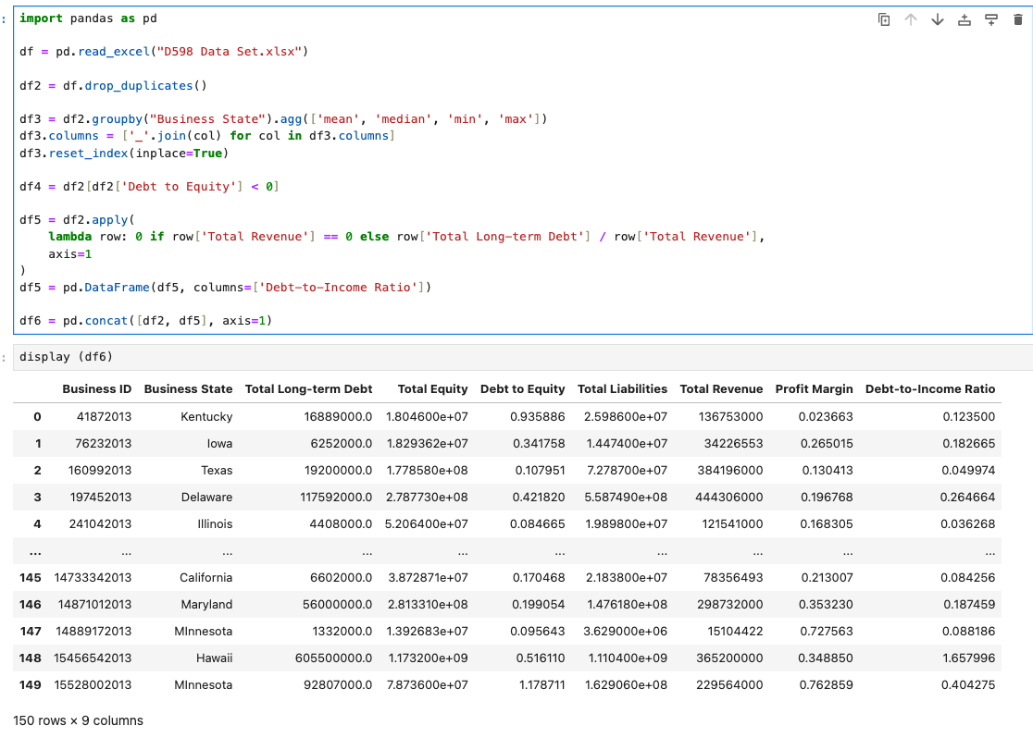
- To begin building the data frames, I first imported the pandas library to read the Excel file.
- After loading the data, I stored it in a DataFrame named df.
- For data cleaning, I removed duplicate records and saved the cleaned data into a new DataFrame called df2.
- In df3, I grouped the data by Business State and calculated key statistics—mean, median, min, and max. I also used the join function to append the original column names to the aggregated metrics for clarity.
- df4 was created to filter and track records where the [Debt to Equity] value was less than 0.
- For df5, I used a lambda expression to create a new column called [Debt-to-Income Ratio]. If [Total Revenue] was 0, the value was replaced with 0; otherwise, it calculated the ratio of [Total Long-term Debt] to [Total Revenue]. The use of axis=1 ensured the operation applied across columns for each row.
- Finally, I concatenated df2 and df5 using axis=1 to merge them side-by-side as columns in a combined DataFrame.

B. Provide 4 customized data visualizations.
- Step 2: Import Matplotlib and seaborn
import matplotlib and seaborn
Step 3: generate Data
Graph 1: Total Debt to Equity by State
Code: 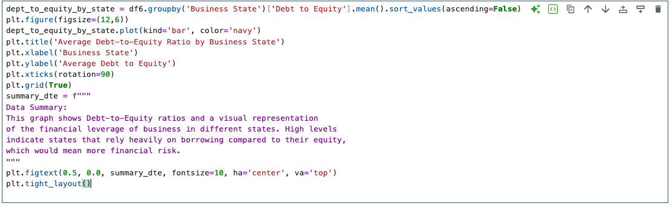
Graph: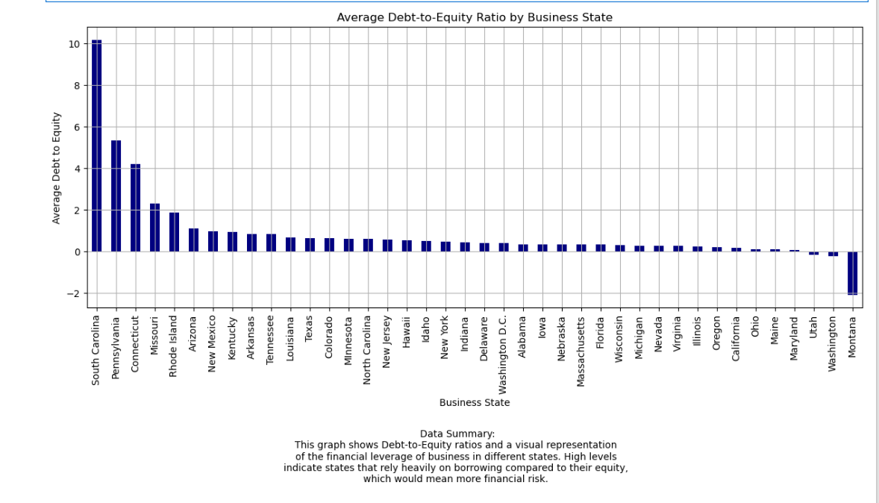

Graph 2: Total Debt to Income by State
Code: 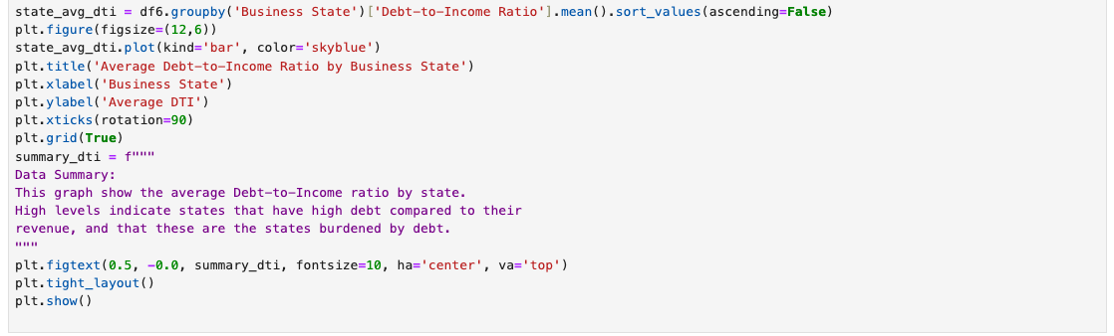
Graph: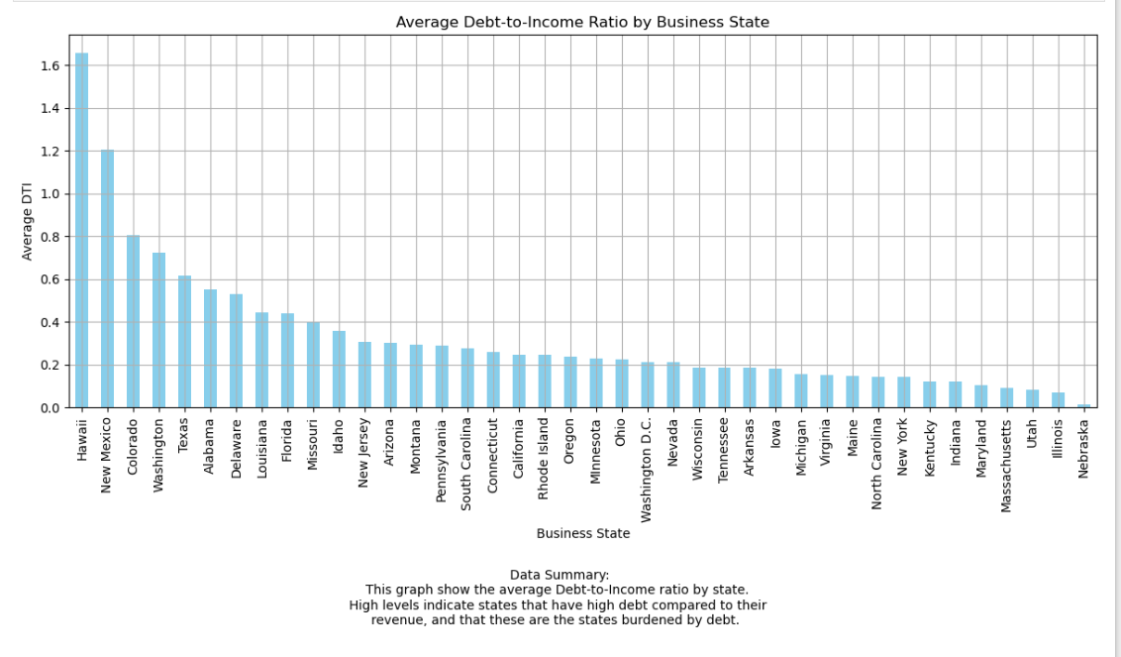

Graph 3: Total Long Term Debt vs Total Revenue
Code:
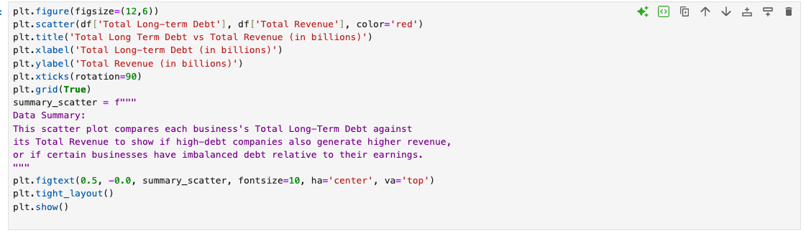
Graph: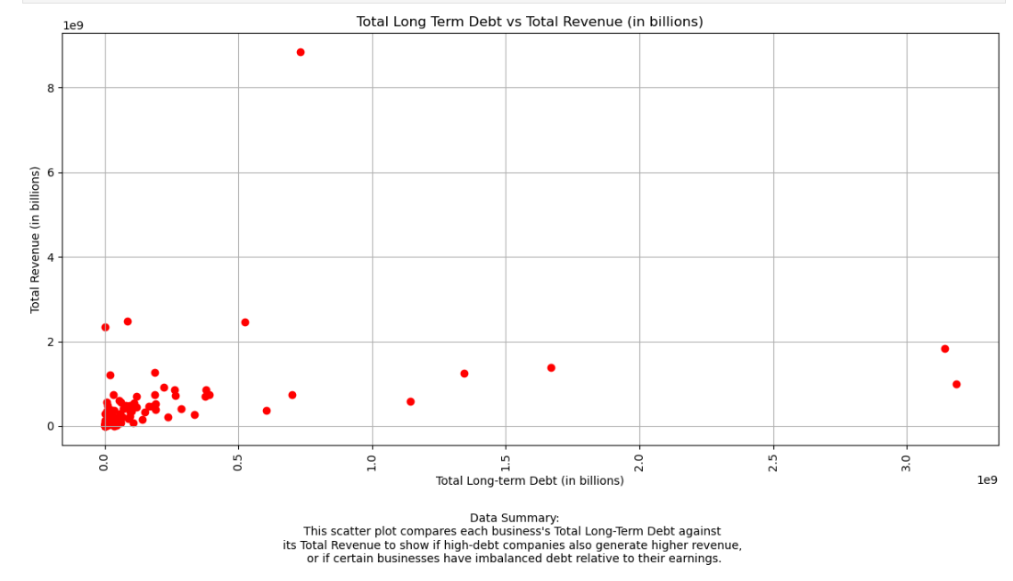

Graph 4: Number of Business in Each State
Code:
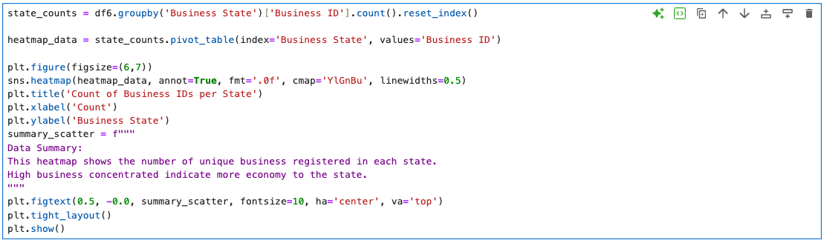
Graph:
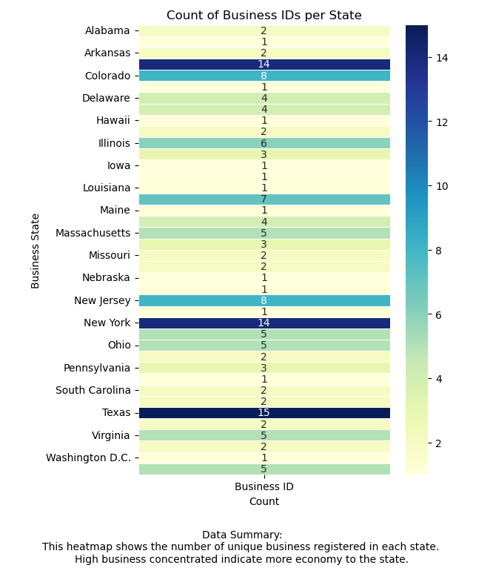
C. Explain how customized visualizations in part B were created.
To generate visualizations for the data frames, I imported both Matplotlib and Seaborn. Graphs 1, 2, and 3 were created using Matplotlib, while Seaborn was integrated specifically for Graph 4 to produce a heatmap.
For each graph, I followed a consistent structure:
- Performed calculations such as sum, average, or count grouped by state—except for Graph 2 (scatter plot), which simply plotted the raw values of [Total Long-term Debt] and [Total Revenue] without grouping.
- Plotted the graphs using the calculated data frames, specifying the kind of plot (e.g., bar, heatmap, scatter), and customized visual aspects such as color.
- Set the figure size for consistent presentation and readability.
- Added a title to clearly describe the graph’s purpose.
- Defined the x-axis label for context.
- Defined the y-axis label for context.
- Created a summary text to explain what the graph represents.
- Positioned the summary text below the graph using coordinates (0.5, 0.0) after the graph and set it to top center. I also set the font size to 10 for all.
- Applied tight_layout() to ensure that all elements fit well within the figure without overlap.
- Displayed the final graph using plt.show().

Reference:
- External resources not used in this submission

